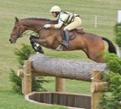
Lucinda Green returns to WA!
21st & 22nd February 2020 (Friday & Saturday)
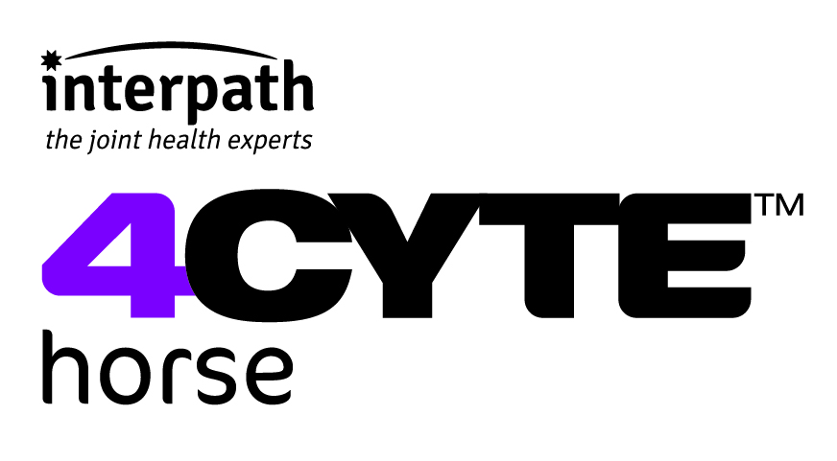
Former World champion and twice European champion, Lucinda Green has won the prestigious Badminton Horse Trials an unprecedented six times on six different horses and she now combines her huge bank of knowledge and her love of the sport to help improve the safety of Eventing.
Cost: $380 per horse, this covers both days of the clinic. Every rider will receive a 250ml pack of Epiitalis FORTE just for coming along!
Plus, the first 5 retired racehorses and the first 5 horses over 10 years old to sign up will receive a $100 bursary making clinic fee just $280 (limited to one discounted horse per rider and one discount per horse).
Venue: Friday – Sustainable Equitation in Herne Hill, Saturday – XC Course TBC
Clinic Format: The clinic will focus on safe cross-country riding techniques and is designed to help develop mutual confidence between horse and rider and a safer cross-country ride. Each day you will have a 2-hour group lesson with Lucinda (approx. 5 riders, grouped according to level).
Day one will be conducted in a grass jumping arena and will focus on cross-country techniques using show jumps to build corners, arrowheads, bounces etc.
Day two will be out on the Cross-Country course where riders will be able to put the previous day’s lessons into practice.

Prerequisites:
Riders should be a member of EA, a minimum of 12 years of age and jumping at least 80cm.

Riders Name: ____________________________________ EA Number: _______________
Age (if under 18): ____ Address: _______________________________________________
Email: __________________________________________ Mobile: ___________________
In Case of Emergency Contact: ________________________ Mobile: _________________
Horse Name: _______________________________________________ Age: __________
Horse Racing Name (if applicable for discount):___________________________________
Competition level/experience: ________________________________________________

Full payment will be required to confirm your place. Return form to: info@swequestrian.com.au. Get in quick as places are limited. If booking a discounted place please confirm by email before processing payment.

Bank: CBA BSB: 066-115 Acc: 1096 4638 Acc Name: Sophie Warren

Refunds:
- Scratchings will receive a full refund if the place can be filled either from the waiting list or by the person scratching. By registering for a place you agree to these terms. The organiser must be contacted before any clinic places are transferred.

Disclaimer: The organisers’ do not accept liability for any injury, death or loss, however caused, to any of those attending the above clinic in whatever capacity. The organisers’ shall not be liable to make good any losses or consequential losses caused by any delays in or cancellations of the above events due to circumstances beyond their control.

